**Project Report**



**Fall 2024**

**CSE-411L Intro to Game Development Lab**

Submitted by:

**Ali Asghar(21PWCSE2059)**

**Muhammad Sadeeq(21PWCSE2028)**

**Suleman Shah(21PWCSE1983)**

**Muhammad Shahab(21PWCSE2074)**

Submitted to:

**Engr. Abdullah Hamid**

Date:

**9th February 2025**

**Department of Computer Systems Engineering**

**University of Engineering and Technology, Peshawar**

Contents

Introduction 4

Gameplay Features 4

Top-Down Gameplay 4

Player Character - The Assassin 4

1. Knife 4

2. Silenced Gun 4

Stealth and Assassination 5

Detection System 5

Level Objectives and Approaches 5

1. Stealth Kill (Silent Approach) 5

2. Discreet Gunshots (Silenced Approach) 5

3. Avoid Combat (Non-violent Approach) 5

4. Failed Stealth 6

3D Environments 6

Input Controls 6

Combat Mechanics: 6

Contribution of Each Group Member 7

Muhammad Sadeeq’s Contribution as a 3D Artist 7

1. Environment Assets 7

2. Character Models 8

3. Weapons & Items 8

Tools & Software Used 9

Challenges & Solutions 9

Ali Asghar’s Contribution as Main Logic Designer 10

1. Gameplay Mechanics 10

2. AI & Game Systems 10

Challenges & Solutions 11

Suleman Shah’s Contribution as Level and Game Designer 12

Level Design & Environment Development 12

Challenges & Solutions 12

Muhammad Shahab’s Contribution as UI Designer 13

User Interface Design 13

Challenges & Solutions 13

Code Screenshots 14

PlayerController Script 14

Enemy AI Script 19

GameManager Script 23

Bullet Script 25

CameraFollow Script 25

Cutscene Script 26

LaserCollider Script 27

SettingsController Script 27

Game Screenshots 29

Topics Covered from the Course 31

Conclusion 31

**Project Report: League of Assassin’s**

# Introduction

League of Assassins is a top-down stealth action game set in meticulously crafted 3D environments where players assume the role of an elite assassin. With a knife for silent kills and a gun equipped with a silencer for discreet ranged eliminations, players must infiltrate various locations to eliminate high-profile targets while staying undetected.

# Gameplay Features

The following are the main gameplay features of this game.

## Top-Down Gameplay

The game features a top-down perspective, providing players with a strategic view of the environment and allowing them to plan their movements and stealth tactics effectively. The 3D environments are rich and detailed, offering multiple pathways, hiding spots, and opportunities for environmental interaction, which are crucial for completing stealth-based missions.

## Player Character - The Assassin

Players take on the role of a skilled assassin belonging to the prestigious League of Assassins. The character is equipped with two primary weapons:

### Knife

A silent, close-range weapon that allows the player to eliminate targets quietly and without alerting others. It is ideal for stealth kills when the player is up close to enemies.

### Silenced Gun

A range weapon with a silencer attached, ensuring that the gunshots do not alert nearby enemies. However, the gun has limited ammunition, so players must use it strategically, balancing between silent knife kills and careful gunshots when needed.

The key challenge is to carefully use both weapons in combination, determining when to rely on stealthy knife kills or when the silenced gun is necessary to eliminate distant or harder-to-reach targets.

## Stealth and Assassination

At the heart of the gameplay is the need for stealth. The environment is full of patrolling enemies and obstacles, and players must navigate these spaces without being detected. Enemy AI is programmed with dynamic behavior patterns, including patrolling and standing guard

## Detection System

Enemies have a field of vision. If the player enters this field, they risk being detected. The player’s goal is to avoid detection by using cover, staying out of sight, and using the silenced gun or knife when appropriate. The player must plan their approach carefully to avoid triggering alarms or being seen.

## Level Objectives and Approaches

Each mission has a central target the player must eliminate. There are multiple ways to complete the objectives:

### Stealth Kill (Silent Approach)

The player avoids detection by using the knife and silenced gun to take out enemies quietly. The target is killed without alerting anyone, and no chaos is caused. This approach reflects a true assassin's skill and rewards players with high fame.

### Discreet Gunshots (Silenced Approach)

The player uses the silenced gun to eliminate the target or any necessary guards. Although this still maintains a level of discretion, it’s riskier than relying on the knife. Players must be cautious with the gun’s limited ammo.

### Avoid Combat (Non-violent Approach)

The player may decide to avoid killing other enemies entirely, focusing only on the target. By bypassing most guards and using stealth to reach the target undetected, the player avoids unnecessary bloodshed, which can impact the ending.

### Failed Stealth

If the player is detected during the mission, the game forces a shift to combat mode. The player may then choose to fight their way out or attempt a hasty escape, but they will suffer a loss in reputation, and the mission ends in failure.

## 3D Environments

The game takes place in a detailed urban scene that features both exterior and interior spaces. The environment includes intricately designed buildings, furnished interiors, and various props that enhance immersion. Players can navigate through open streets, enter buildings, and utilize the surroundings for strategic gameplay. The level design encourages stealth, offering hiding spots, interactive objects, and multiple ways to approach objectives.

## Input Controls

There are two types of controls: Touch-Based (Point & Click) and Joystick.

* **Touch-Based (Point & Click):**

Players can tap on the screen to move their character to the selected location. This control scheme is ideal for a more tactical and calculated playstyle.

* **Joystick:**

A virtual joystick allows for full manual movement, giving players precise control over their character’s positioning and actions. The right side of the screen can be used for camera movement, while additional on-screen buttons enable interactions such as crouching, sprinting, and using special abilities. This setup is suited for players who prefer a more hands-on and immersive experience.

## Combat Mechanics:

* When a player is near an enemy, they can use a **melee knife** for a silent takedown.
* If the enemy is within the **laser sight** of the pistol, players can take a ranged shot for a quick elimination.

# Contribution of Each Group Member

The contribution of each group member is described as follows.

## Muhammad Sadeeq’s Contribution as a 3D Artist

As the 3D Artist, Sadeeq was responsible for creating various models essential to the game. These models were designed, textured, and optimized for performance in Unity. Below are the key models he created:

### 1. Environment Assets

* **Walls:** Designed low-poly walls with textures to create an immersive game world.
* **Props:** Created objects such as table, chairs, doors, and lamp to enhance the game environment.
* **Terrain Features:** Modeled, trees, and grass to add realism to outdoor areas.

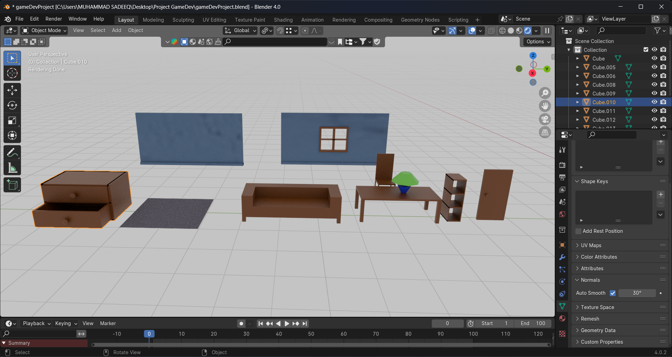

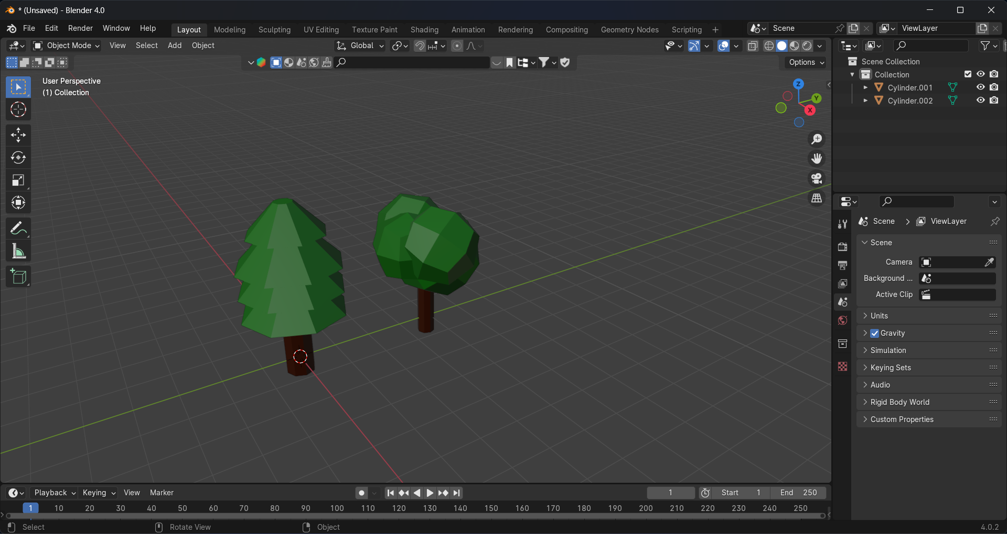

### 2. Character Models

* **Main Character:** Downloaded a 3D model for playable character, fixing and optimization of it mesh, ensuring proper rigging and animation compatibility.
* **NPCs (Non-Playable Characters):** Created enemy NPC from the main character by making changes in it mesh and materials.

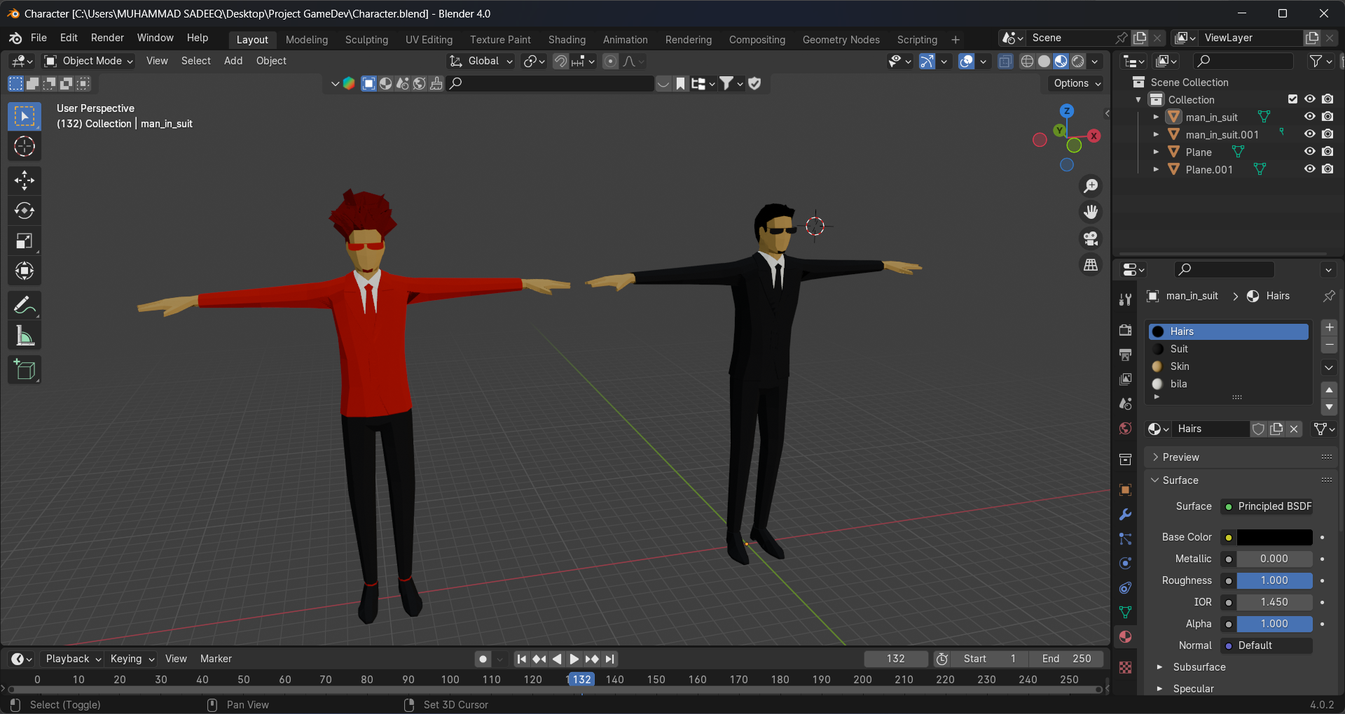

### 3. Weapons & Items

* **Weapons:** Modeled guns, other weapons based on game requirements.
* **Collectibles:** Designed gun boxes, and other collectible items.

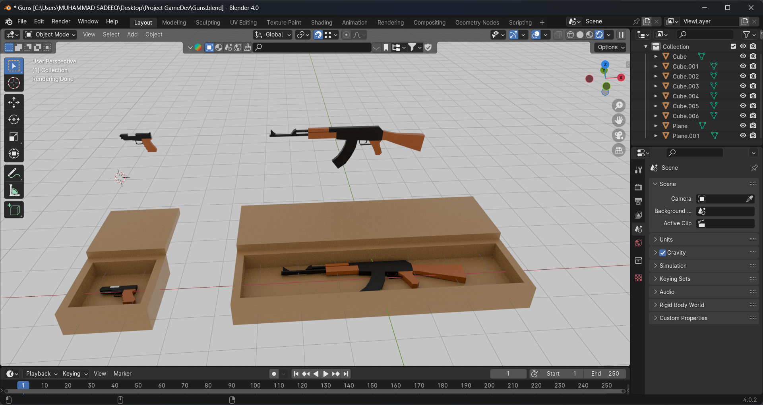

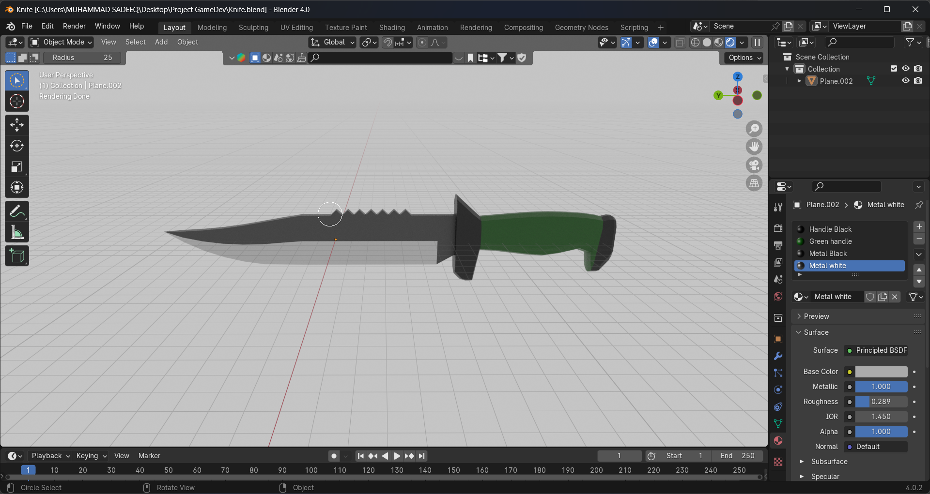

### Tools & Software Used

* **Blender:** 3D modeling, texturing, and UV unwrapping.
* **Unity 3D:** Integration of 3D assets into the game.
* **Mixamo:** For rigging the characters

### Challenges & Solutions

* **Challenge:** High-poly models affected performance.
  + **Solution:** made low-poly asset
* **Challenge:** Texture misalignment issues.
  + **Solution:** Proper UV unwrapping and texture mapping.
* **Challenge:** Importing models with animations.
  + **Solution:** Ensured correct rigging and exported models in FBX format for seamless Unity integration.

## Ali Asghar’s Contribution as Main Logic Designer

As the Main Logic Designer, Ali Asghar was responsible for implementing core gameplay mechanics and system logic. He designed and optimized game interactions, ensuring smooth and efficient execution in Unity. Below are the key areas he contributed to:

### 1. Gameplay Mechanics

* **Player Input Controls:** Developed responsive player movement, handling inputs and physics interactions.
* **Combat System:** Implemented shooting mechanics, enemy AI behavior, and damage calculations.

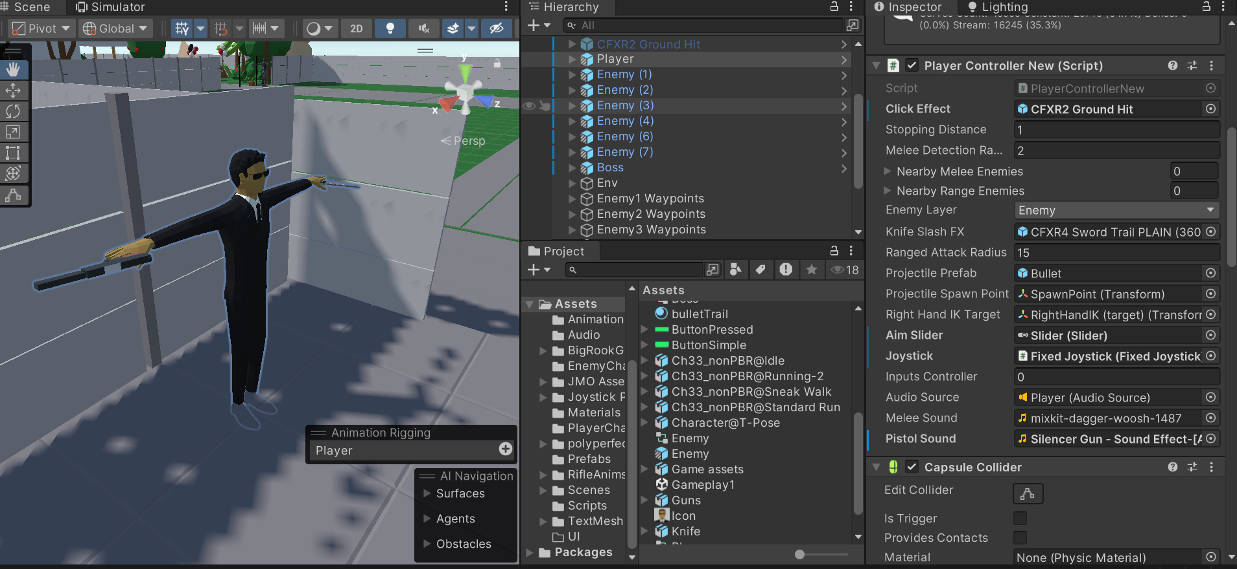

### 2. AI & Game Systems

* **Enemy AI:** Programmed NPC behaviors, including patrolling, attacking, and reacting to the player.
* **State Management:** Utilized state machines to manage different game states such as idle, attack, and chase.

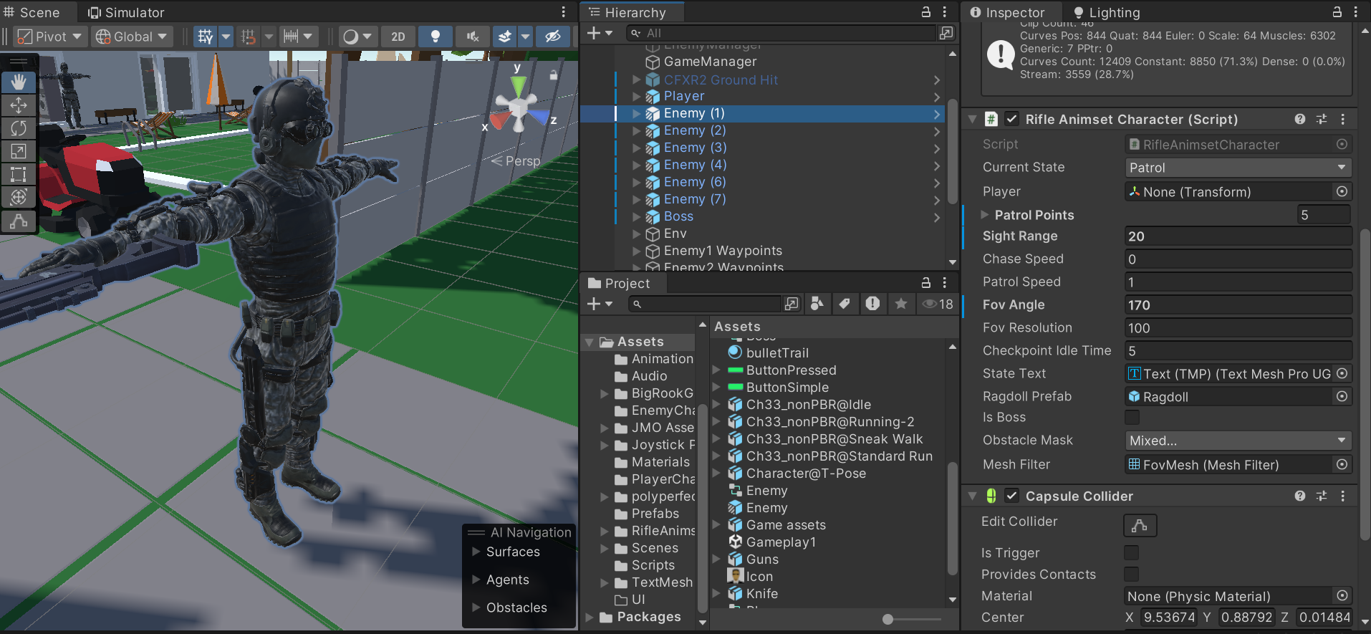

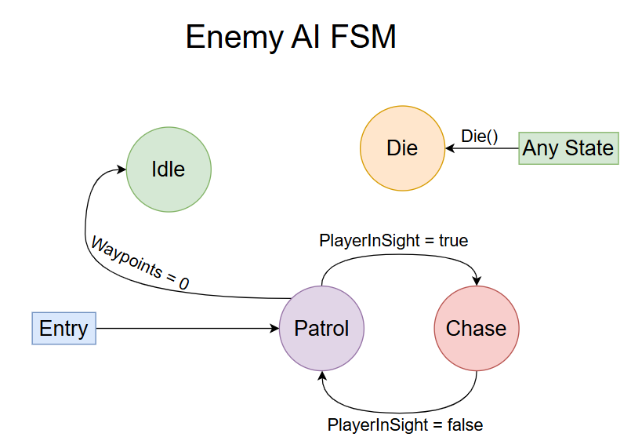

### Challenges & Solutions

* **Challenge:** AI pathfinding was inefficient in complex environments.
  + **Solution:** Implemented NavMesh for dynamic navigation and obstacle avoidance.
* **Challenge:** Player inputs felt unresponsive.
  + **Solution:** Refined input handling with interpolation and better physics calculations.

## Suleman Shah’s Contribution as Level and Game Designer

As the Level and Game Designer, Suleman Shah was responsible for designing engaging game environments and ensuring a seamless player experience. He crafted immersive levels, balanced game mechanics, and optimized player progression. Below are the key areas he contributed to:

### Level Design & Environment Development

* **Map Layouts:** Designed well-structured game levels, ensuring balanced pacing and exploration opportunities.
* **Environmental Storytelling:** Created immersive environments that enhanced narrative and player engagement.
* **Player Navigation:** Designed clear pathways and objectives to ensure intuitive movement and interaction.

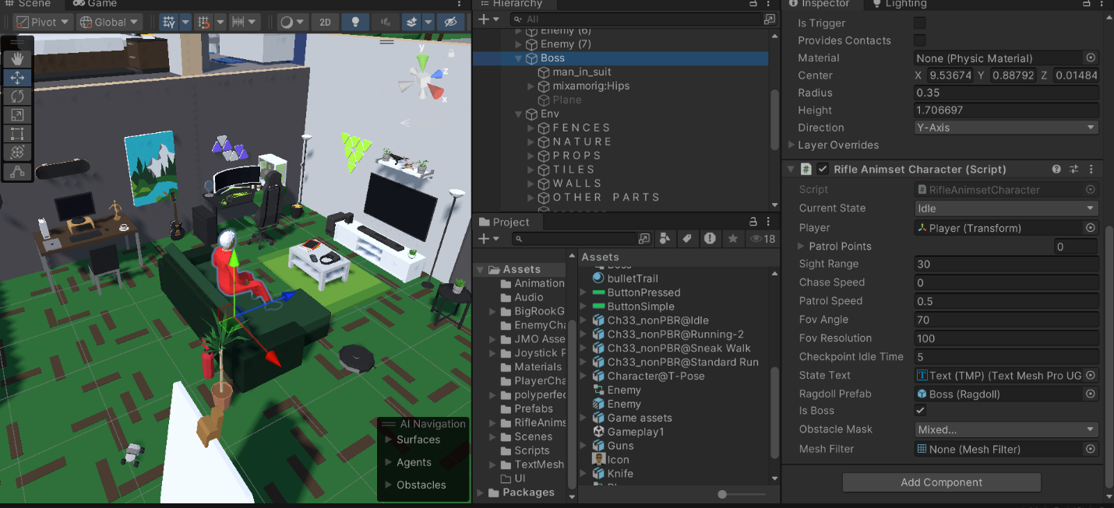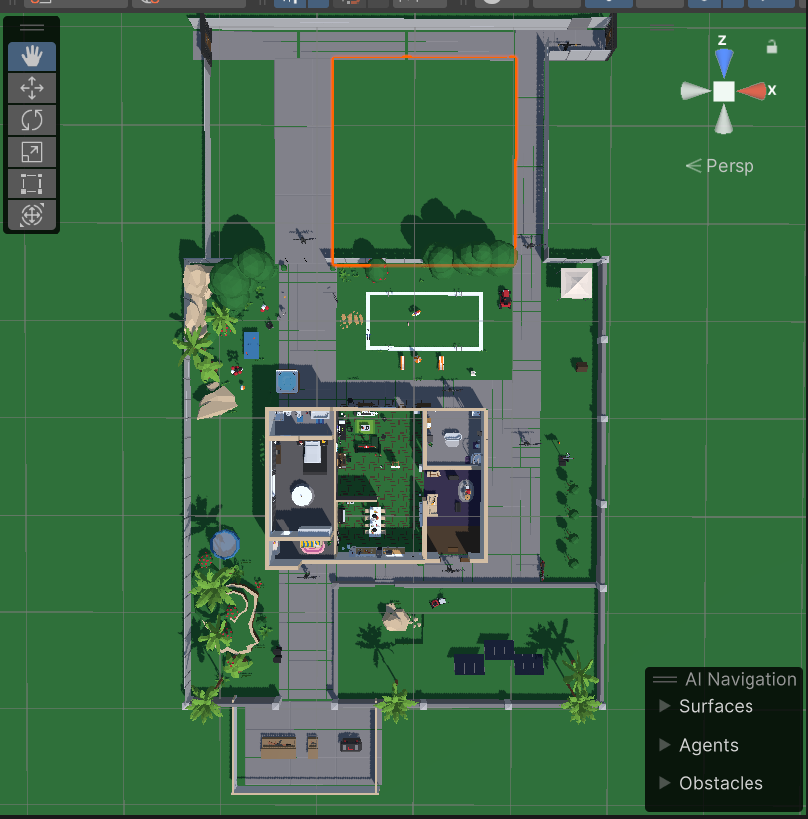

### Challenges & Solutions

* **Challenge:** Levels felt too linear, reducing player engagement.
  + **Solution:** Introduced multiple pathways and hidden areas to encourage exploration.
* **Challenge:** Players struggled with navigation due to poor visibility of objectives.
  + **Solution:** Enhanced visual cues and lighting to guide players more effectively

## Muhammad Shahab’s Contribution as UI Designer

As the UI Designer, Muhammad Shahab was responsible for creating an intuitive and visually appealing user interface. He focused on usability, accessibility, and aesthetic consistency to enhance the player's experience. Below are the key areas he contributed to:

### User Interface Design

**Menu & HUD Design:** Developed user-friendly menus, heads-up displays (HUDs), and interactive elements.



### Challenges & Solutions

* **Challenge:** UI elements were cluttered, reducing usability.
  + **Solution:** Simplified layouts and implemented clear visual hierarchies.
* **Challenge:** Inconsistent UI responsiveness across different devices.
  + **Solution:** Used scalable design techniques and adaptive UI components.

# Code Screenshots

## PlayerController Script

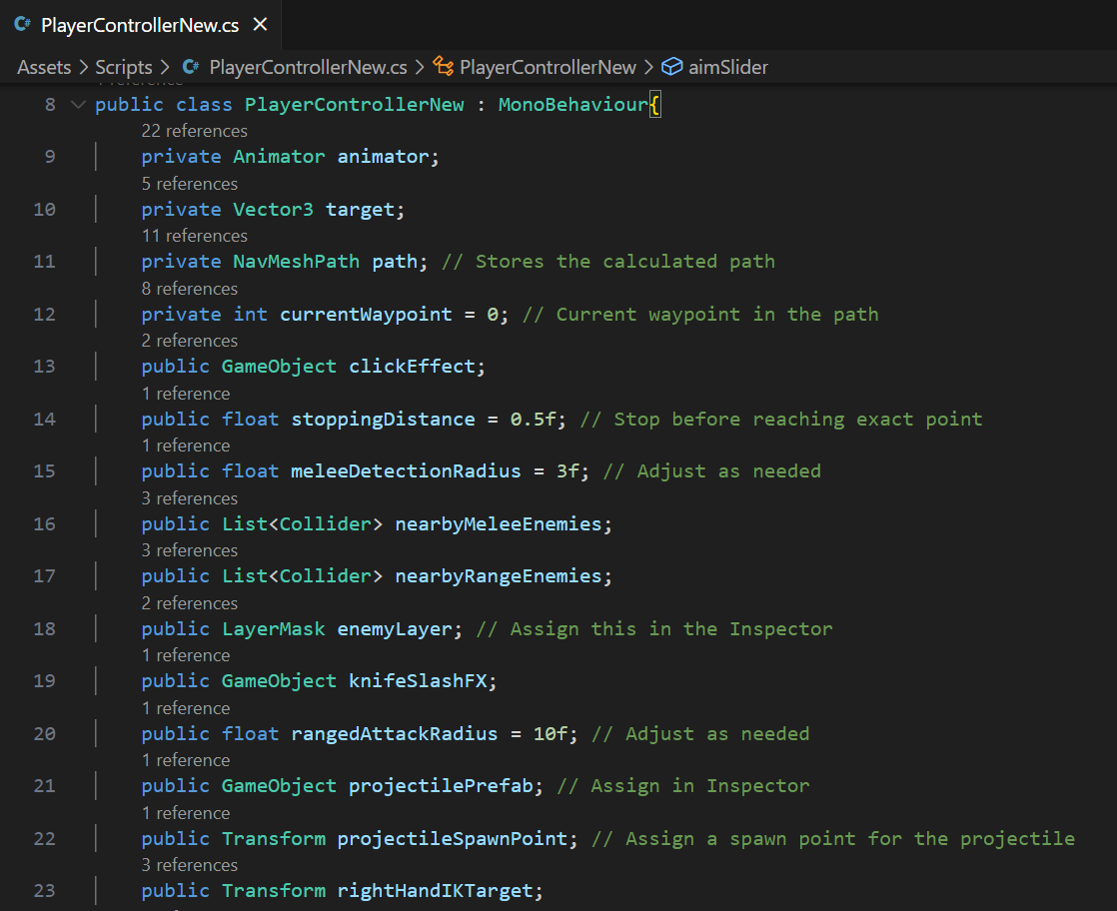

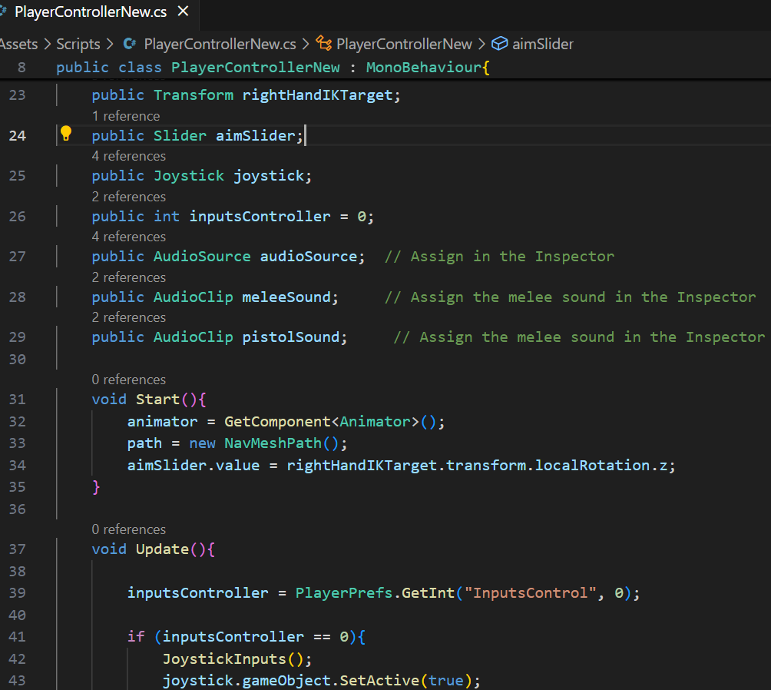



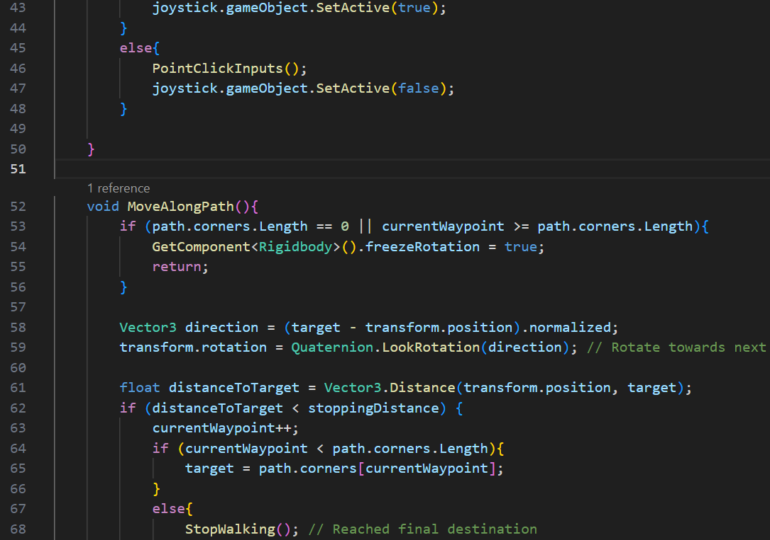

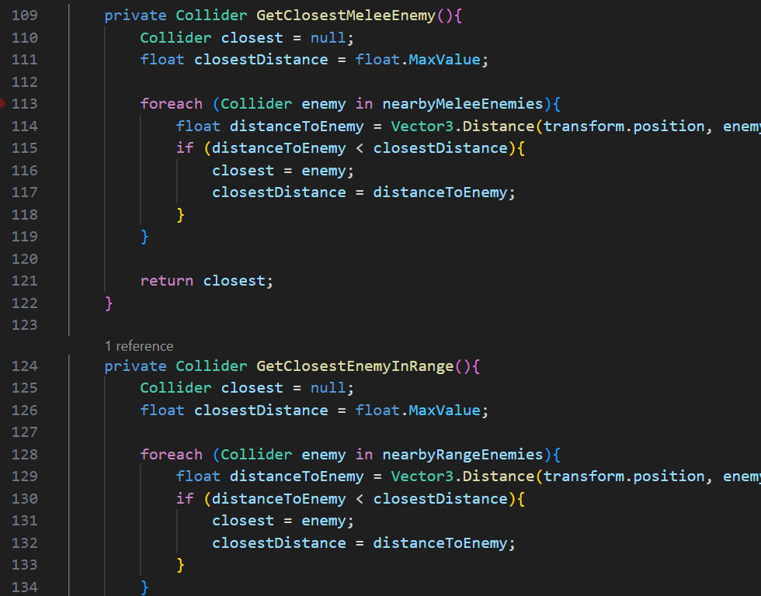



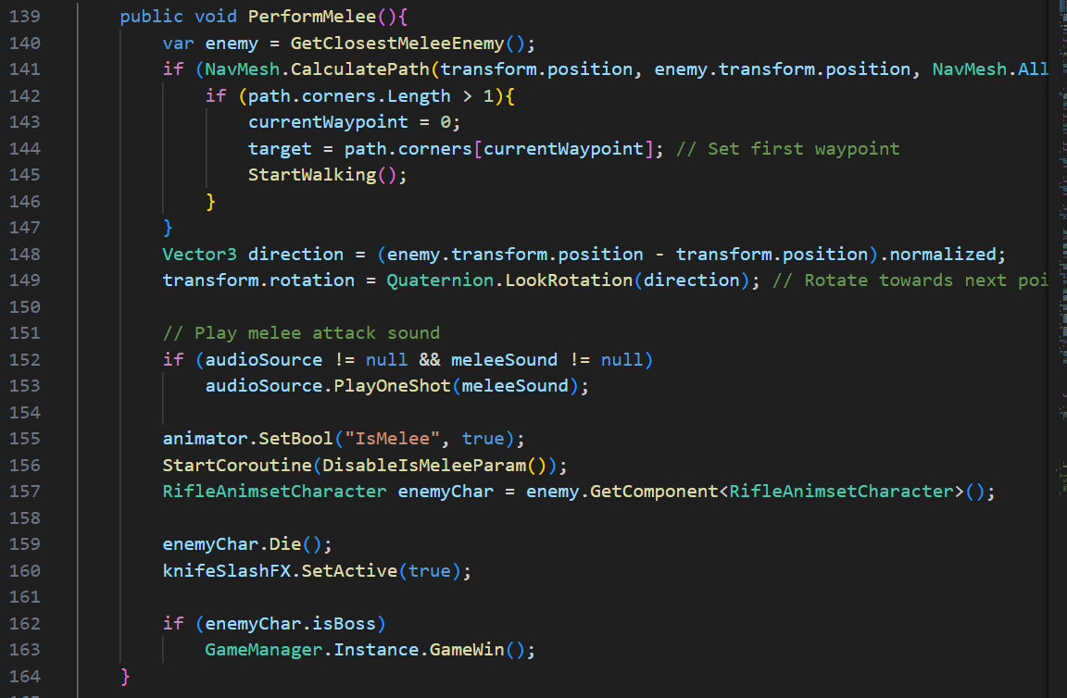

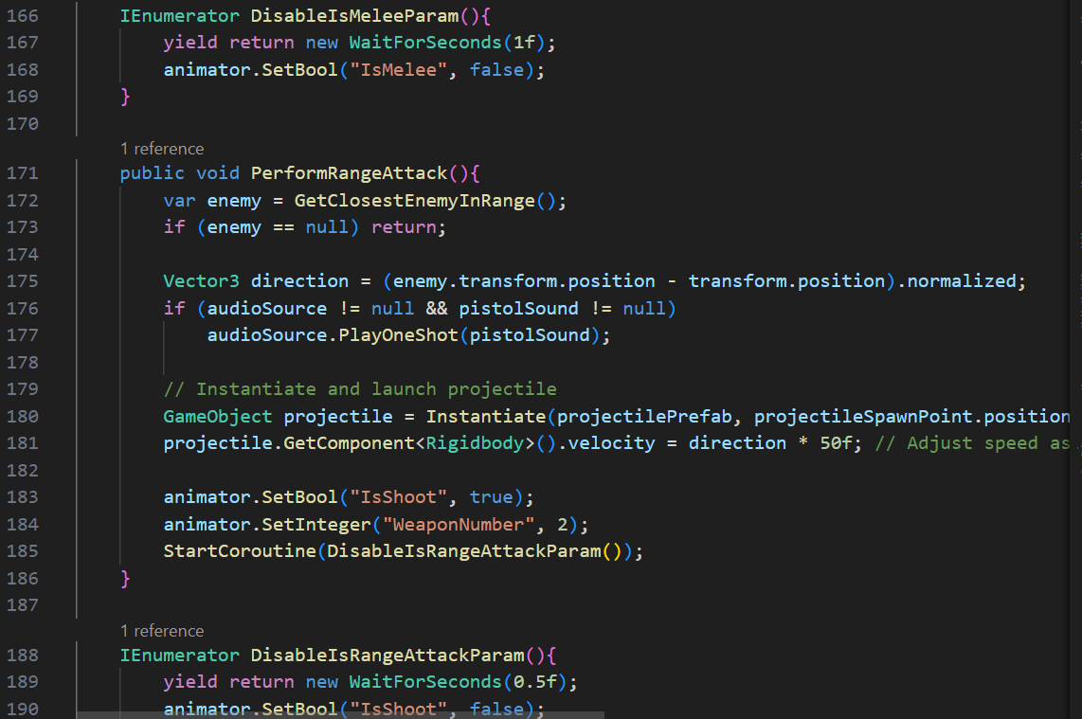



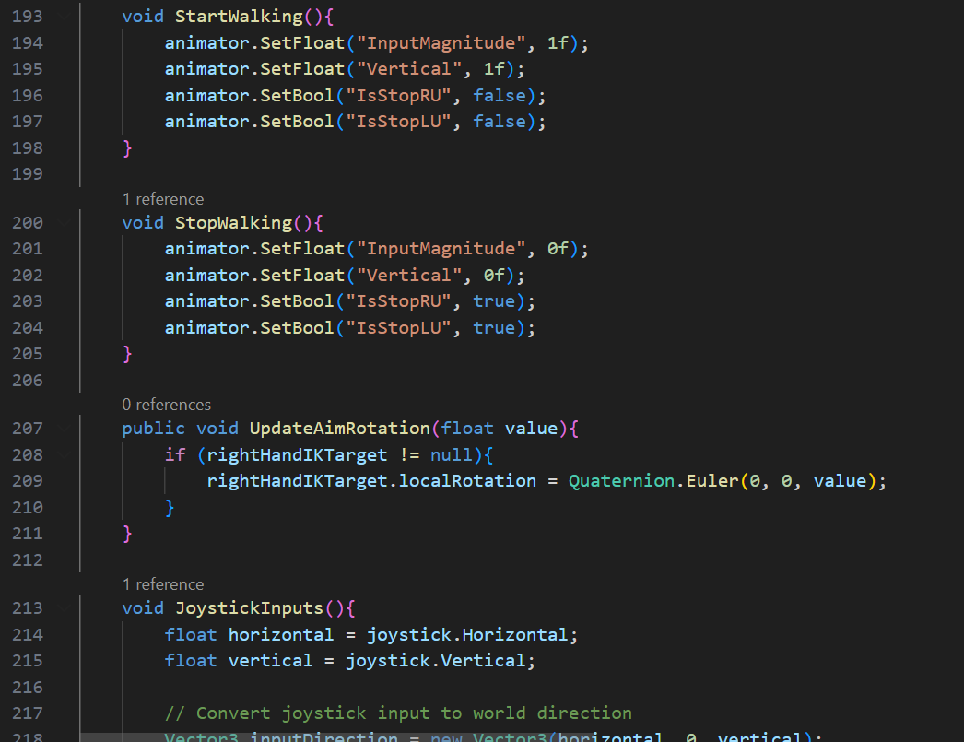

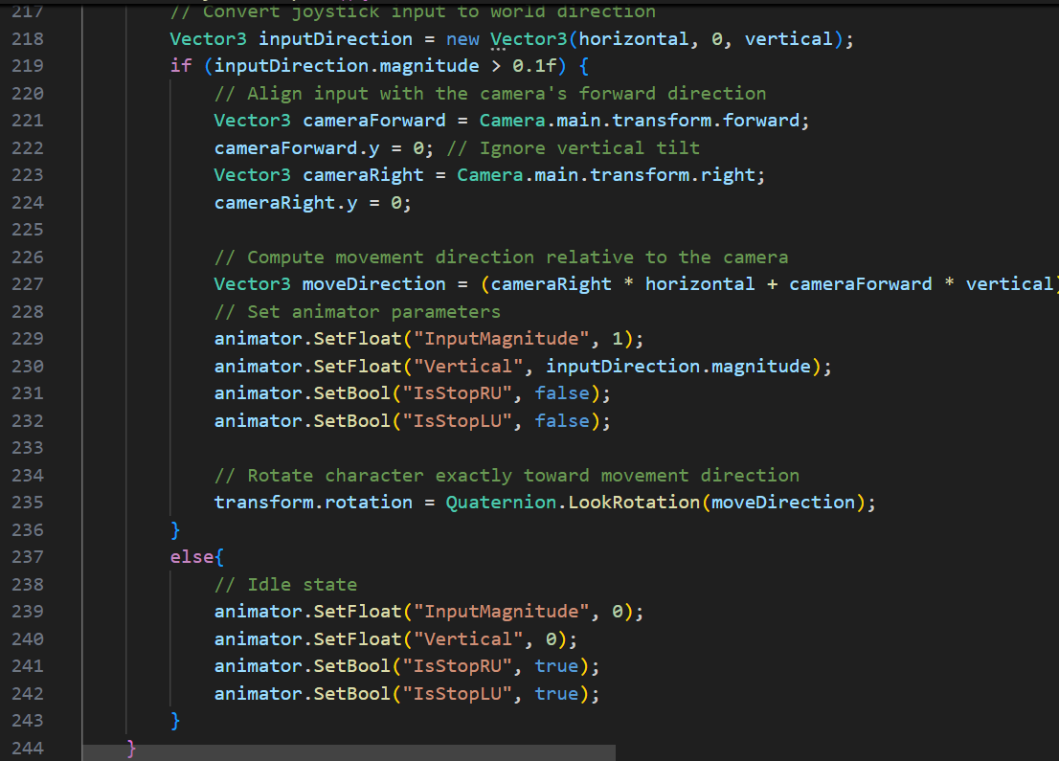

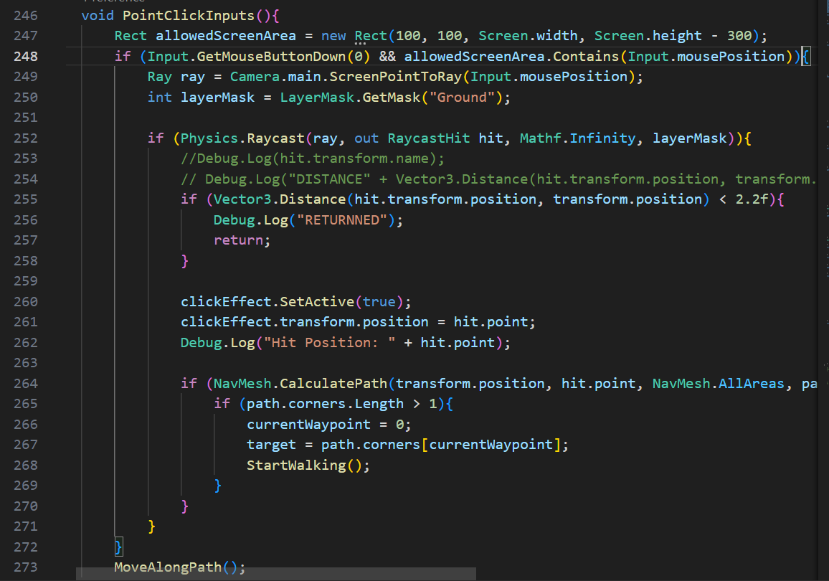



## Enemy AI Script

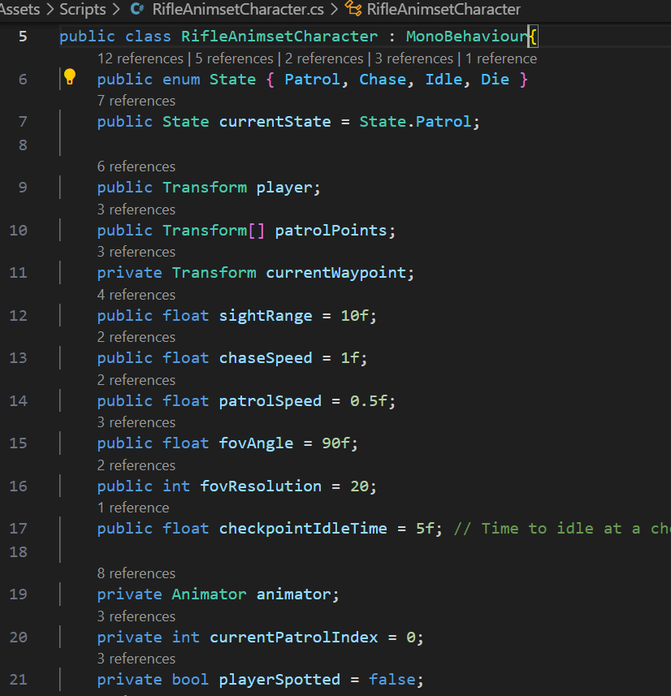

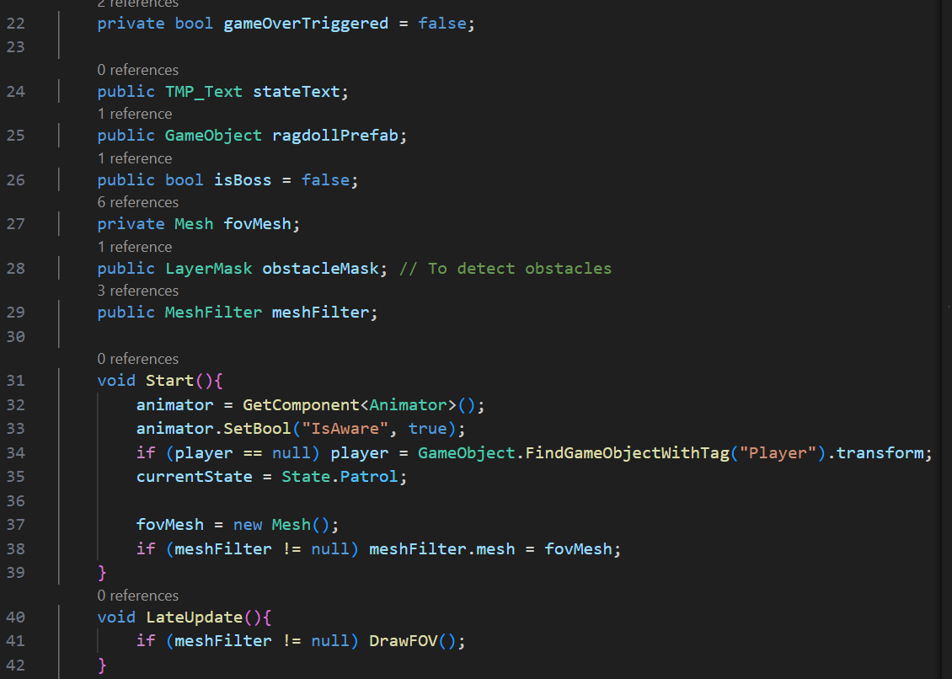

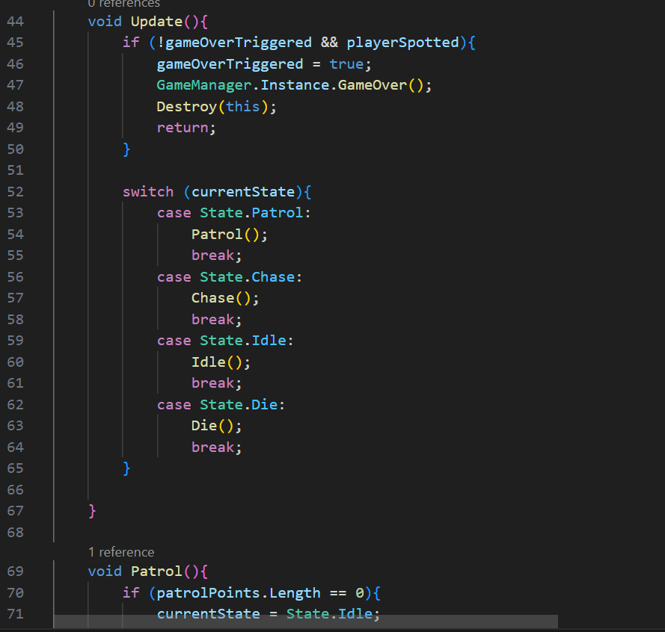

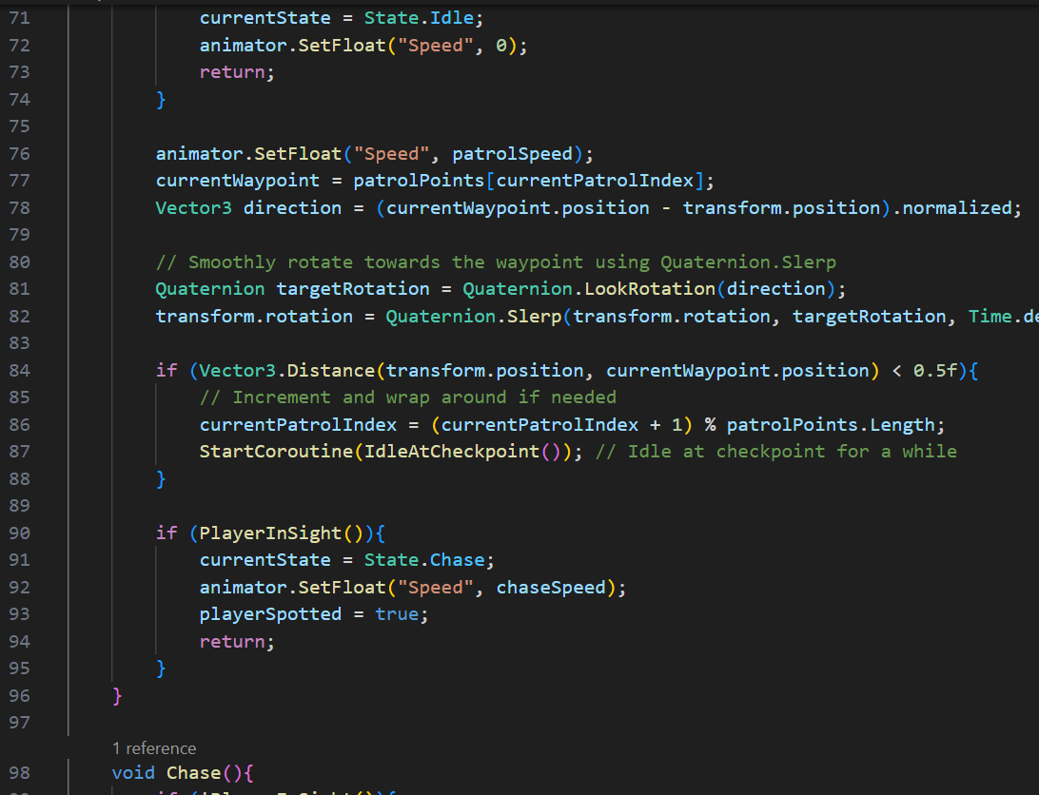

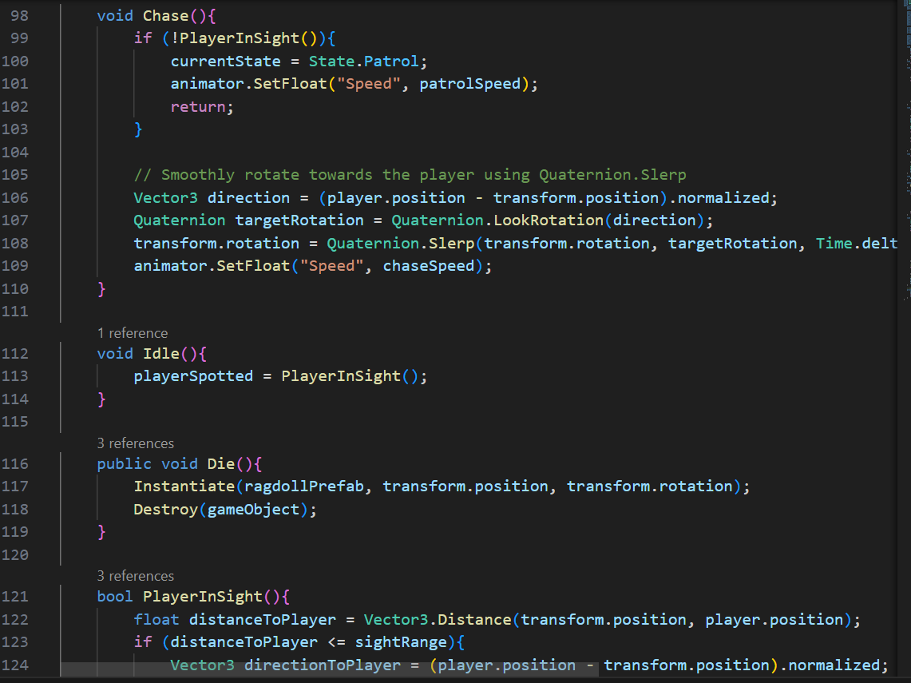

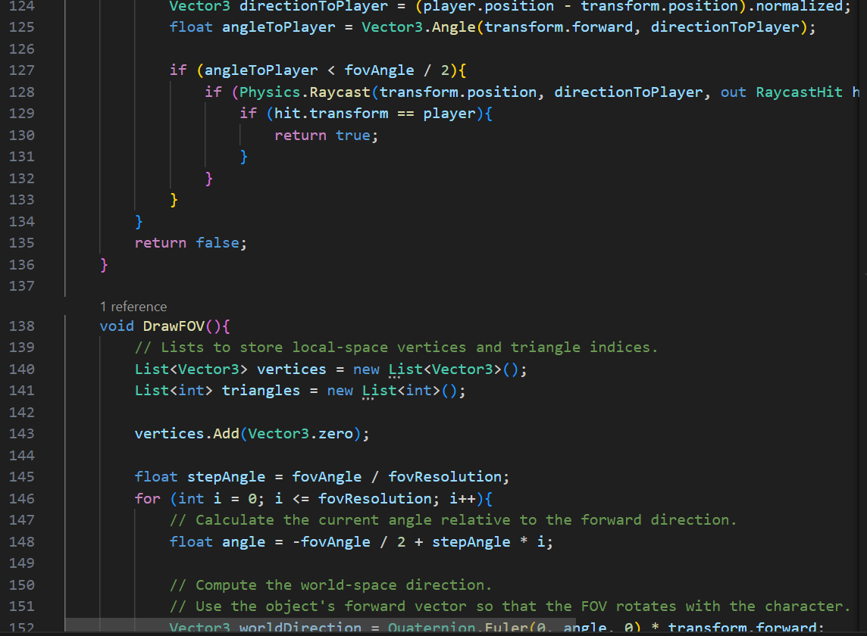

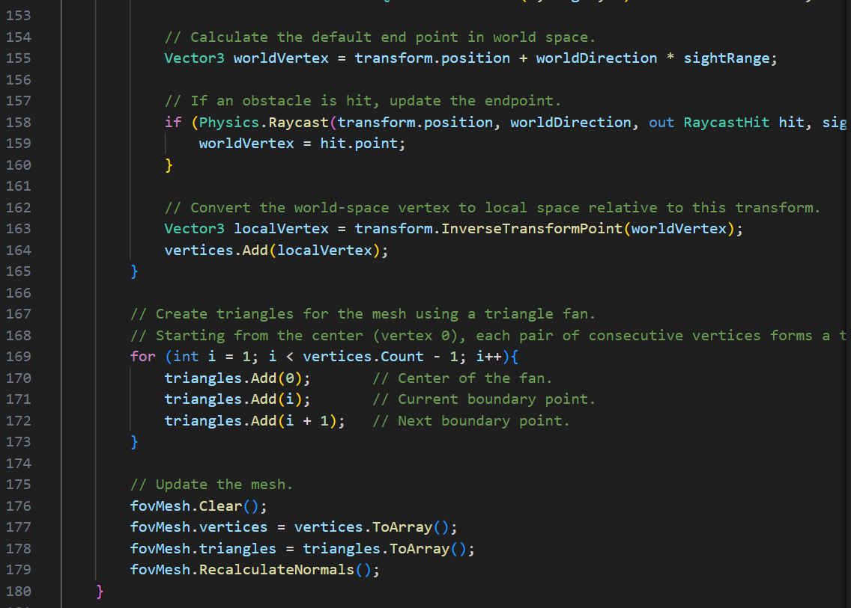



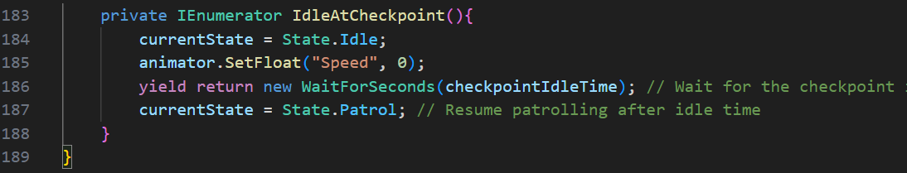

## GameManager Script

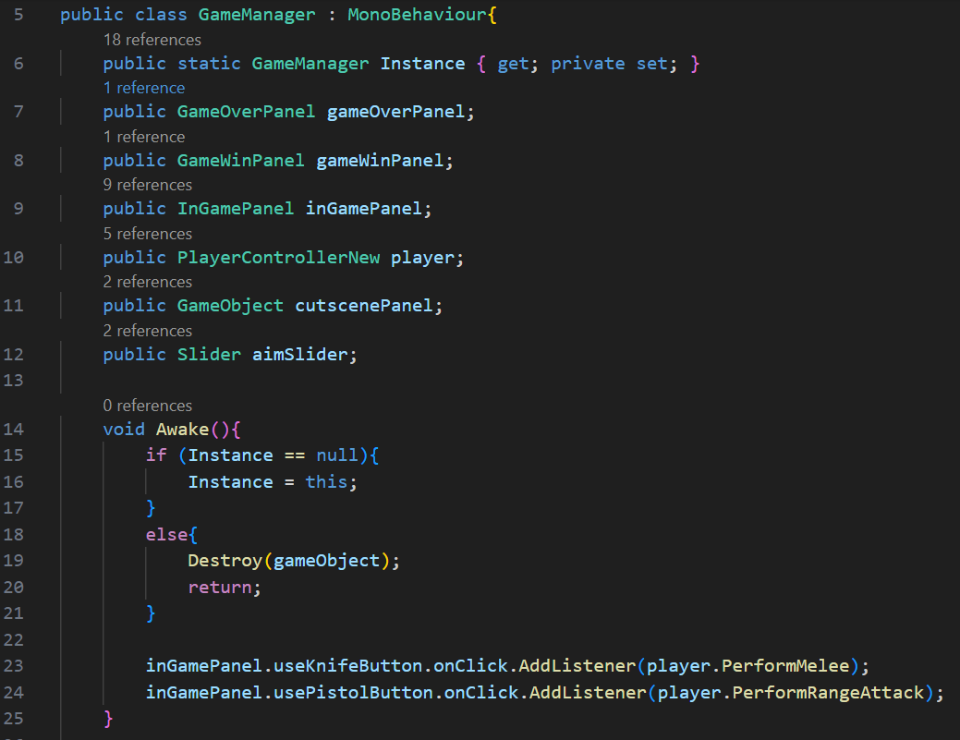

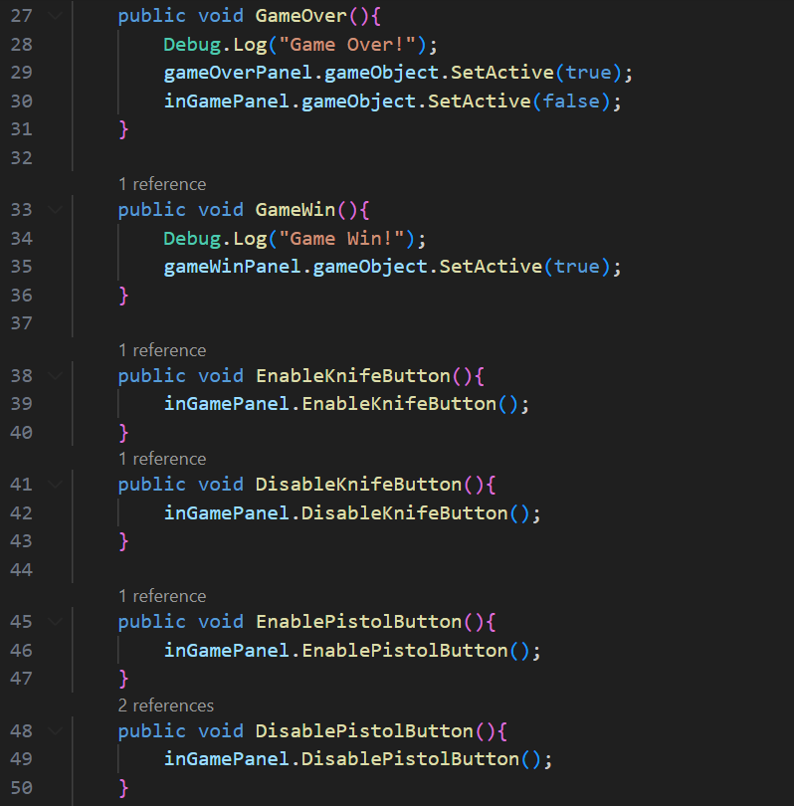

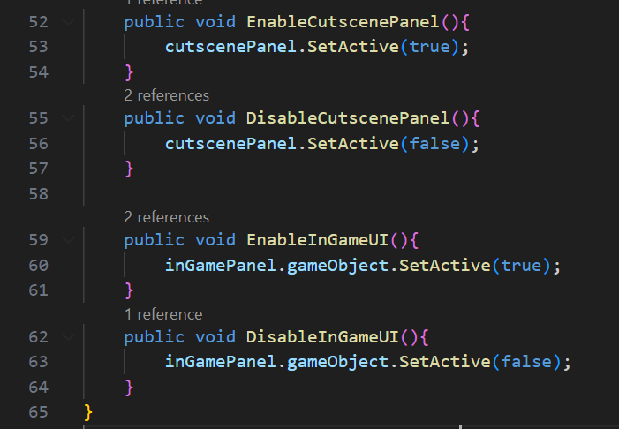

## Bullet Script

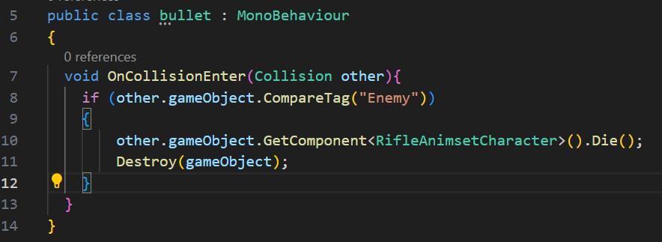

## CameraFollow Script

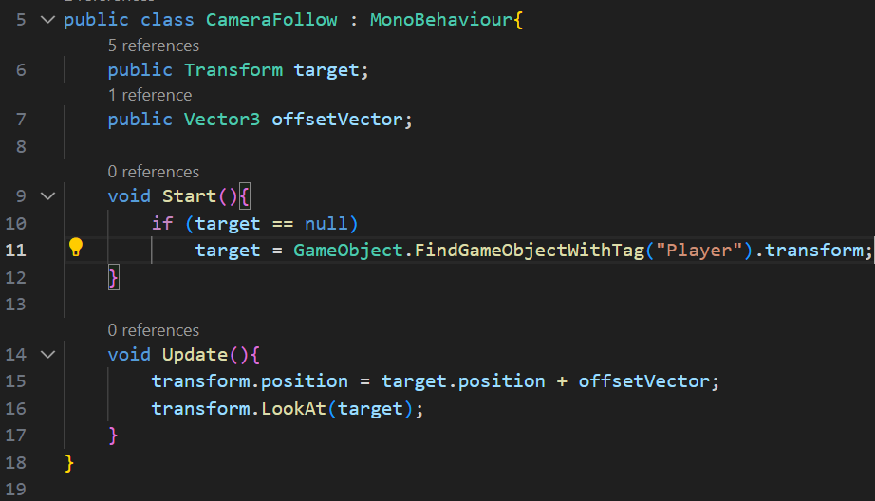

## Cutscene Script

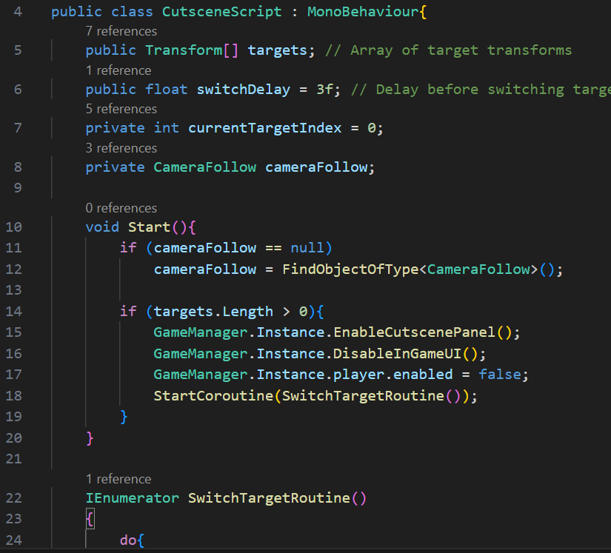

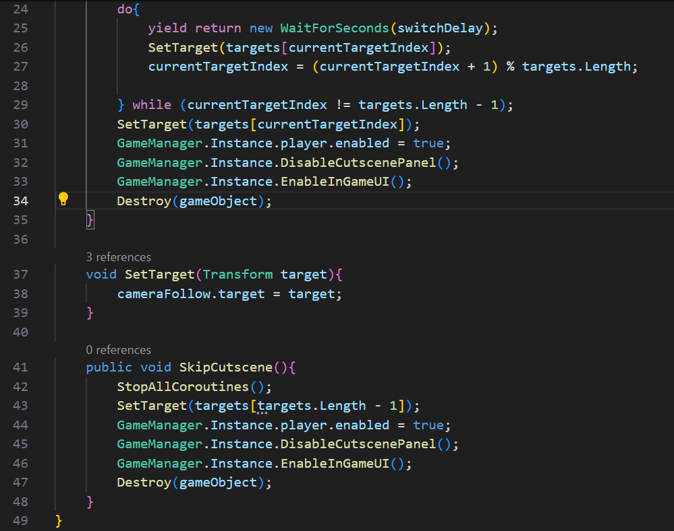

## LaserCollider Script

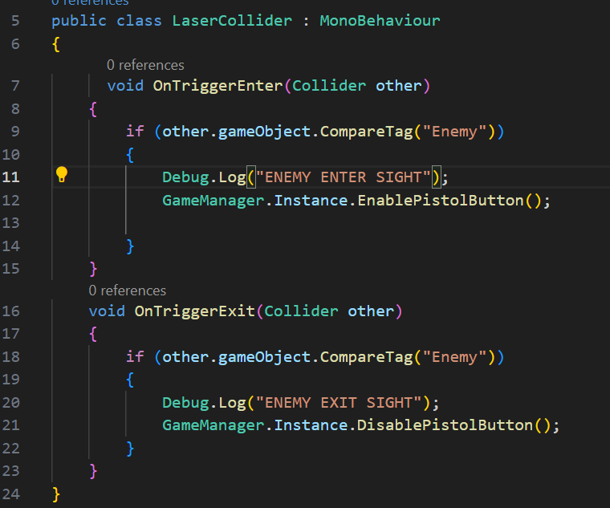

## SettingsController Script

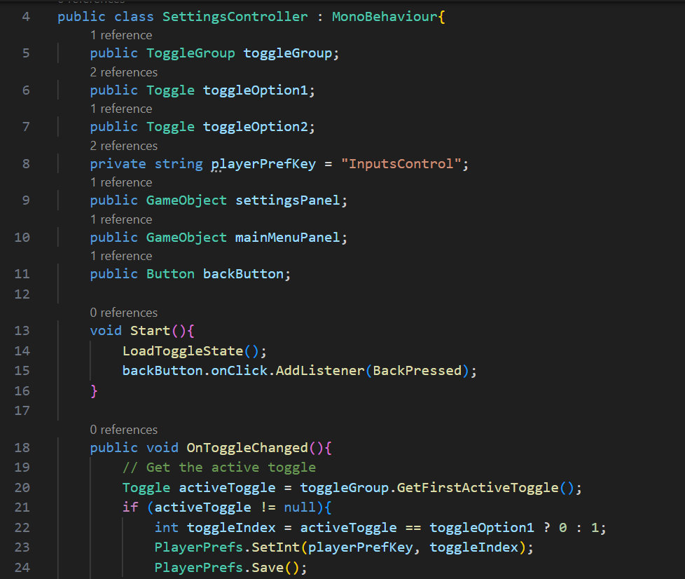

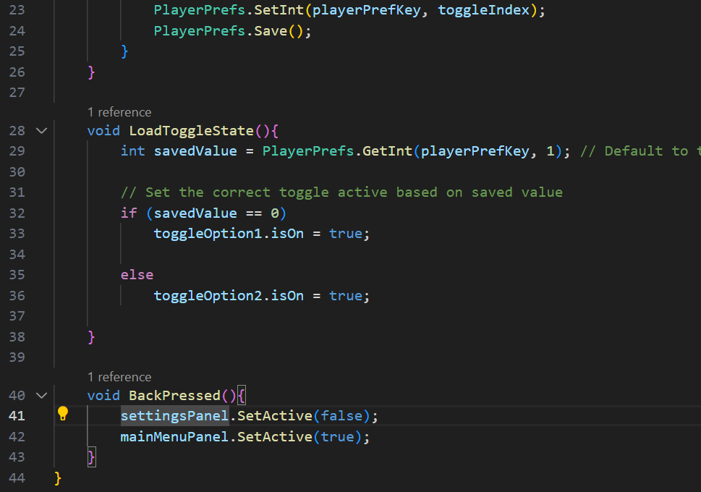

# Game Screenshots

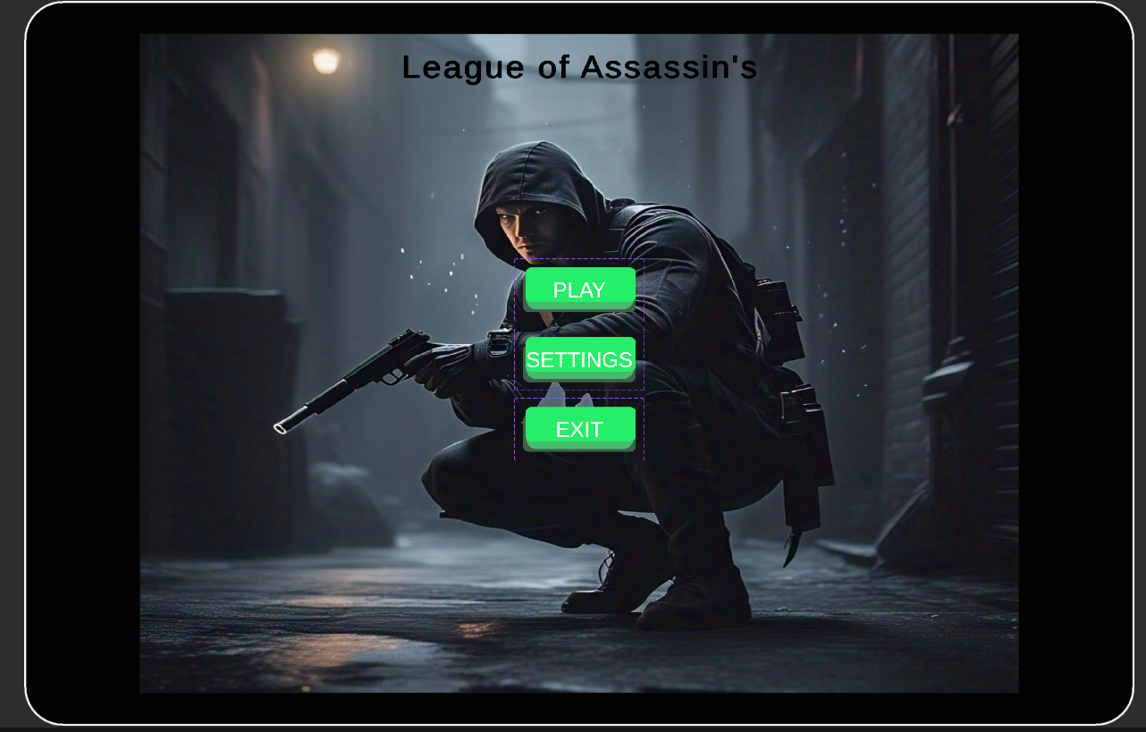

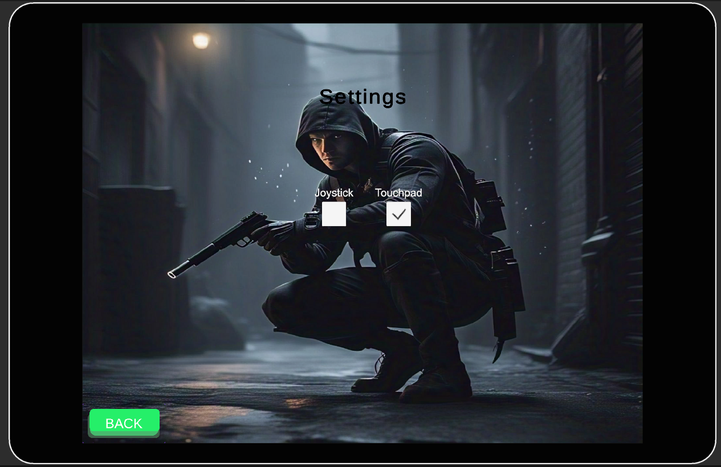

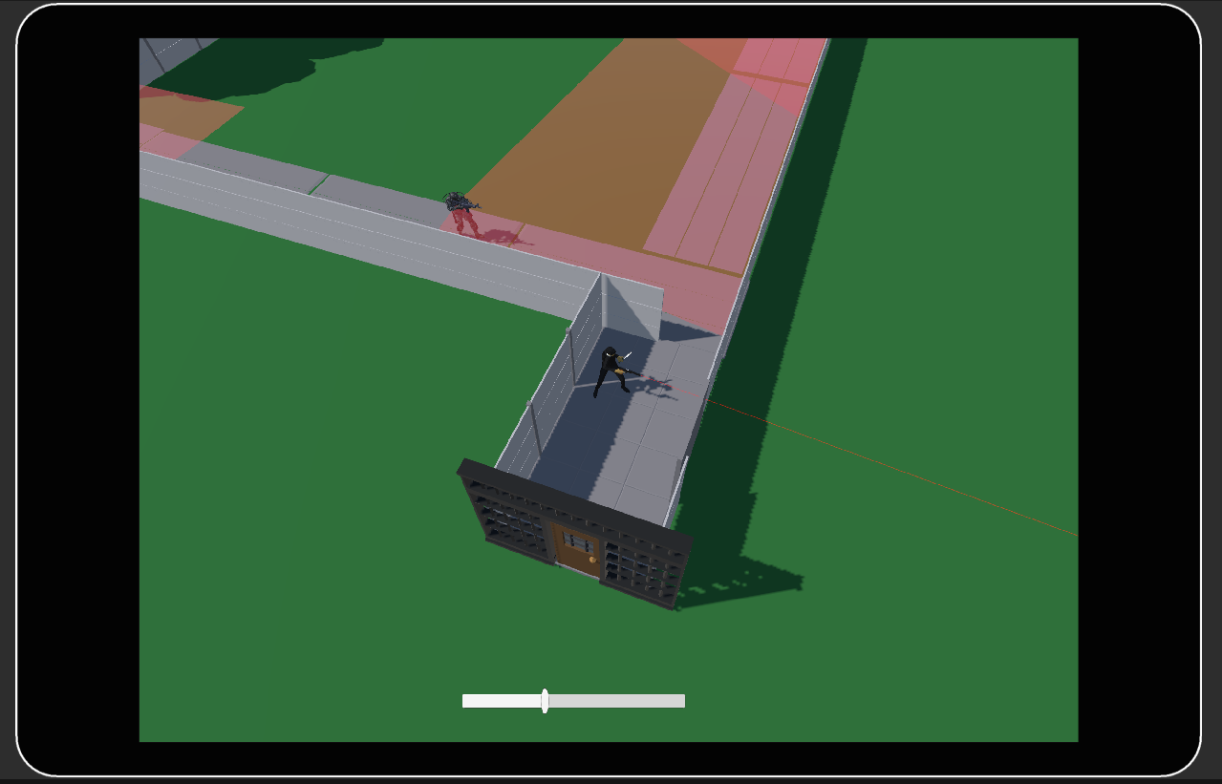

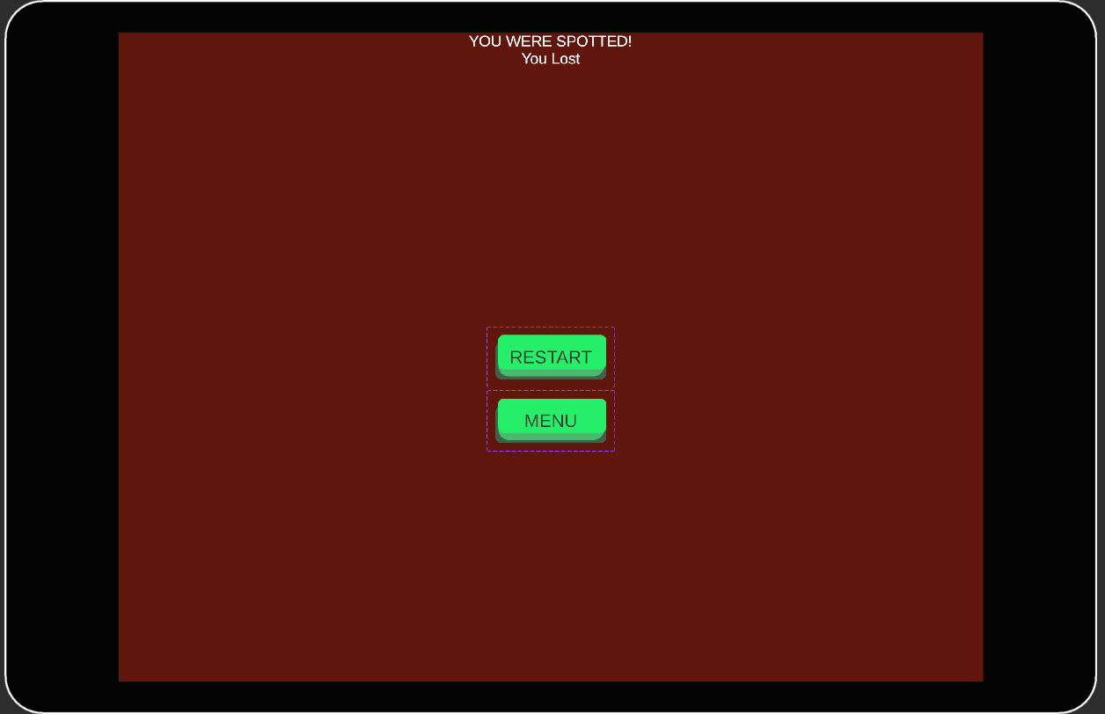

# Topics Covered from the Course

The following topics from the course were covered during the project.

1. Level Designing
2. PlayerPrefs
3. C# Scripting
4. Built-In Unity Methods (OnTriggerEnter, OnTriggerExit etc)
5. Animator Controllers and Animations
6. Input System
7. Unity UI
8. Unity Physics

# Conclusion

League of Assassins offers rich and immersive stealth experience, where careful planning, precise execution, and tactical thinking are essential to success. Whether you prefer silent knife kills, discreet gunshots, or non-violent approaches, the game rewards those who can navigate its dangerous world with finesse and precision. Your reputation as an assassin will shape your journey in the League of Assassins, and only the most skilled will achieve the highest fame and respect.